**Tables and Captions**

**Table 1**. We summarize fleet characteristics for three realized fisheries and compare to the corresponding NWFSC Observer sector description. Parenthetical values represent the percentage of trips which fell within expected ranges. The following fisheries represent (with pink shrimp and limited entry groundfish) the top fifteen realized fisheries by revenue. Fleet characteristics for which no corresponding NWSFC observer sector is present are presented as 95 percentiles for length, latitude and seasonality.

|  |  |  |  |  |
| --- | --- | --- | --- | --- |
| **Fishery**  Sector name if applicable | **Latitude**  decimal degrees | **Catch composition**  % trips multispecies | **Seasonality**  fishing season | **Vessel Length**  ± 1 ft |
| Limited entry groundfish trawl/catch shares | 35.4-49  (100%) | 100%  (87.1%) | year-round | 35-95  (98.9%) |
| Pink shrimp trawl | 35.8-49  (100%) | NA | Apr – Oct  (99.9%) | 38-105  (99.5%) |
| California halibut trawl | 34.05--37.4  (65%) | CA halibut dominated | year-round | 29-71  (99.8%) |
| Dungeness crab pots | 36.8-49.0 | 0% | Oct – Jul | 22-65 |
| Market squid seine | 33.7-37.5 | 1% | May – Feb | 37-80 |
| Albacore troll | 38.2-46.9 | 0% | Jul -- Oct | 24-72.75 |
| Geoduck dredge | 47.0-49.0 | 0% | Year-round | NA |
| Sablefish long-line | 33.2-48.4 | 26.8% | Year-round | 20-56.5 |
| Chinook salmon troll | 35.4-48.1 | 5.6% | Apr -- Oct | 20-50 |
| Sardine seine | 33.7-46.9 | 10.6% | Year-round | 46-80 |
| Spiny lobster pot | 32.7-34.4 | 3.5% | Year-round | 18-42 |
| Red urchin diving | 36.8-49.0 | 0.2% | Year-round | 22-65 |
| Sablefish pot | 34.3-46.3 | 2.2% | Year-round | 25-66 |
| Chinook gillnet | 46.3-48.7 | 3.15% | March -- Oct | 18-32 |
| Spotted prawn trap | 33.2-48.7 | 4.3% | Year-round | 25-73 |
| Pacific halibut longline | 42.7-48.7 | 1.5% | Jun -- Oct | 26-76 |

**Figures**

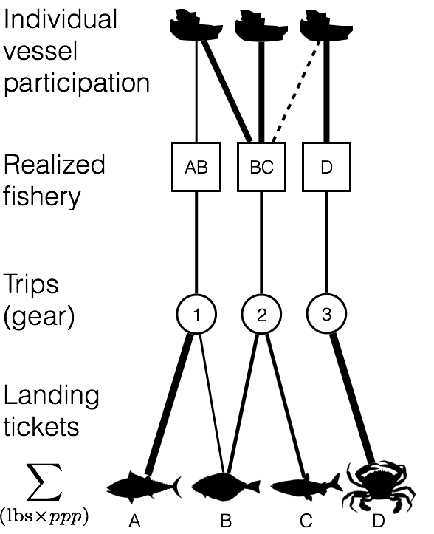

**Figure 1**. Using landing tickets we used price per pound (*ppp*) and landed weight to calculate revenue per species per trip. We aggregated these landings to trips and grouped trips by gear. In each gear partition we identified realized fisheries by measuring pairwise similarity of each trip’s revenue composition of catch using the Hellinger distance, and clustered using infoMap. Using these fishery designations, we mapped participation at the vessel level and quantified revenue diversity.

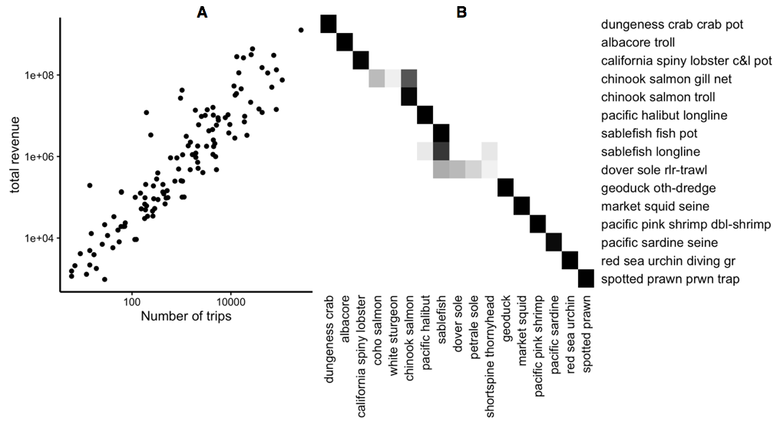

**Figure 2:** A) Comparison of effort and revenue for all realized fisheries between 2006-2014.

B) Species composition for fifteen ten realized fisheries (rows), accounting for 90% of the total revenue derived from commercial fisheries landings. Cell color represents the proportion of landings for which each species (columns) is responsible. Most of the biggest realized fisheries are composed of primarily a single species, but dover sole roller-trawl, for example, is multispecies.

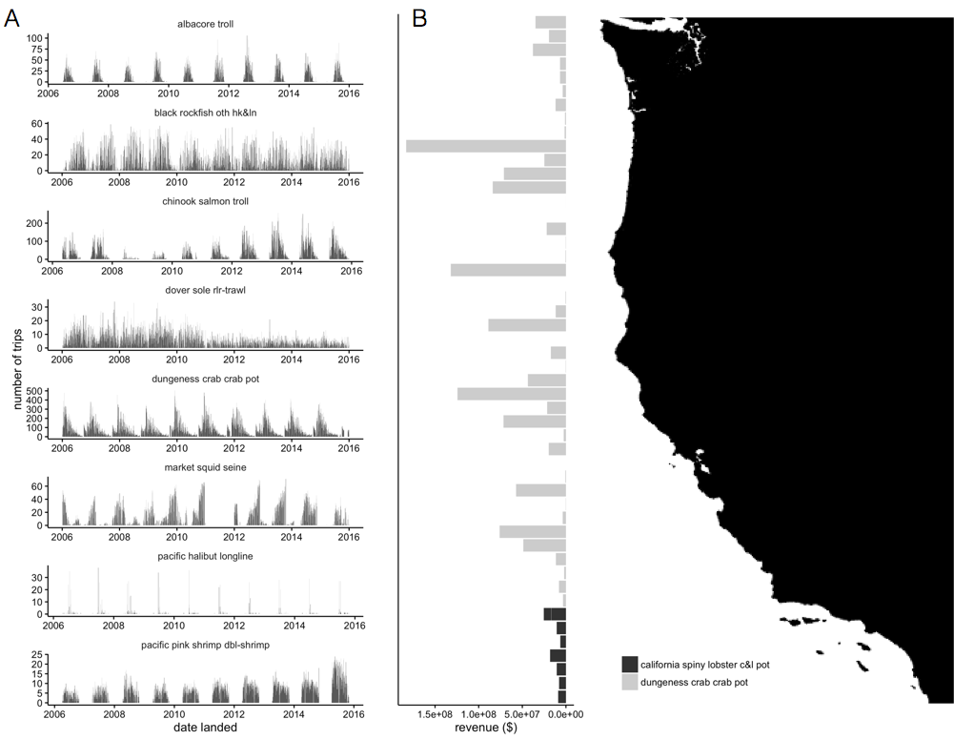

**Figure 3**: A) Seasonality of five major realized fisheries between 2009-2010. Distinct seasonal patterns are observed in Dungeness crab, market squid and pink shrimp fisheries. B) Spatial structure of landings for two example fisheries between 2009-2010. Landings are binned by latitude. Pink shrimp trawl is landed further north, while groundfish trawl landings are distributed more evenly across the coast.